A
Project Report
on
“RideMate”
(Cab Booking System)

Submitted in partial fulfilment of requirement for the
Diploma in Computer Science & Engineering
(Year 2024–2025)

Under the Supervision of
Mr. Ravi Asthana (Lecturer of C.S.E.)

Submitted to :- Submitted By:-
Mr. Rahul Singh Shailesh Pratap Singh
Lecturer (C.S.E.) Sumit Kumar Paswan
Ayush Srivastava

Government Polytechnic Aadampur, Tarabganj, Gonda


PREFACE

This project report titled “RideMate (Cab Booking System)” is submitted as part of the academic curriculum for the Diploma in Computer Science.

To develop a cab booking system that allows users to book rides and track their real-time status, while providing admin the ability to manage the platform by blocking or unblocking users and drivers to maintain service quality and safety.

I express my sincere gratitude to my project guide, Mr. Ravi Asthana (Lecturer of C.S.E.), and my institution for their valuable support and guidance. I would also like to thank my team members for their encouragement throughout the project.

Through this project, I gained hands-on experience in developing web-based applications using MERN Stack and MongoDB.

Shailesh Pratap Singh
Sumit Kumar Paswan
Ayush Srivastava

CERTIFICATE

I certify that the project titled “RideMate (Cab Booking System)” submitted in partial fulfilment of the requirements for the Diploma in Computer Science & Engineering at Government Polytechnic Aadampur, Tarabganj, Gonda is my original work.

This project has been developed by me under the guidance of Mr. Ravi Asthana (Lecturer of C.S.E.), and has not been submitted to any other institution or university for the award of any degree, diploma, or certification.

All information, data, and references used in the project have been acknowledged appropriately. I accept full responsibility for the content and findings presented in this project.

Signature of the Student Signature of the Guide
Shailesh Pratap Singh Name: Mr. Ravi Asthana
Sumit Kumar Paswan Designation: Lecturer of C.S.E.
Ayush Srivastava

Date: _ _ /_ _ /_ _ _ _

ACKNOWLEDGEMENT

I would like to express my sincere gratitude to Government Polytechnic Aadampur, Tarabganj, Gonda for giving me the opportunity to undertake this project work titled “RideMate (Cab Booking System)” as a part of the curriculum.

I am deeply thankful to my project guide, Mr. Ravi Asthana (Lecturer of C.S.E.), for their invaluable guidance, constant support, and encouragement throughout the development of this project. Their expertise and feedback greatly enhanced the quality of my work.

I also wish to thank the faculty and staff of My College Government Polytechnic Aadampur, Tarabganj, Gonda for providing the necessary resources and support.

Lastly, I would like to thank my family and friends for their unwavering support, motivation, and understanding during the course of this project.

Shailesh Pratap Singh
Sumit Kumar Paswan
Ayush Srivastava
Date: _ _ /_ _ /_ _ _ _

Signature

ABSTRACT

“RideMate” is a dynamic web-based Cab Booking System developed to simplify and digitize cab service operations for users, drivers (captains), and administrators. It facilitates ride booking, real-time tracking, and secured ride confirmation, ensuring a reliable and seamless transportation experience.

Users can register, login, book rides, view captain details, and track ride status in real-time. Once a captain accepts a ride, an OTP is automatically generated and sent to the user. The ride officially starts only after the captain verifies this OTP from the user.

Captains can view ride requests, accept them, track users' locations, enter OTPs for ride confirmation, and finish the ride upon completion. Both the captain and user can view the live ride location on the map throughout the trip.

Admins have full control over the platform – they can block or unblock both users and captains to maintain service quality and security.

INTRODUCTION

“RideMate” is a modern cab booking system designed to replace traditional ride-hailing methods with a digital, user-friendly, and secure web-based platform. It supports three roles: User, Captain (Driver), and Admin, offering unique features for each to ensure smooth operation and communication.
Users can easily book rides, receive ride confirmation via OTP, and track their journey in real-time. Captains receive ride requests, accept them, verify OTPs from users before starting the ride, and finish rides upon completion. Admins monitor the system and control user/captain access.

Need of This
- User-Friendly Ride Booking:
Book rides without calling or waiting; quick and hassle-free.

- Secure Ride Start:
OTP verification ensures authorized ride confirmation.

- Real-Time Tracking:
Both user and captain can see the ride’s real-time location on the map.

- Admin Control:
Admin can block/unblock users or captains in case of misuse.

- Improved Safety and Transparency:
Ride start only after OTP verification, and tracking avoids misuse.

- Digital Recordkeeping:
All ride details and ride statuses are stored digitally.

- No Need for Third-Party Apps:
Complete in-house platform tailored to local or institutional needs.

Problem Statement
Traditional cab booking relies on physical contact or third-party apps which:
- Lack OTP-based ride confirmation.
- Don't allow real-time admin control over user or captain access.
- Often lack direct, real-time tracking for both parties.
- Are not tailored for custom or small-scale deployment (e.g., college or campus transport).

Objective
- For Users
- Register and login securely.
- Book cabs with a few clicks.
- Track captain’s live location.
- Receive OTP for ride confirmation.
- Monitor the ride in real-time.

- For Captains (Drivers)
- Accept ride requests from users.
- Track user location and navigate.
- Collect OTP from user to start the ride.
- Finish the ride after drop-off.
- Track ride status live on the map.

- For Admins
- Manage user and captain accounts.
- Block or unblock users/captains if needed.
- Monitor system activity for misuse or error.

Tools/software/Hardware Used

- Frontend Technologies
- HTML
- CSS
- JavaScript
- Tailwind CSS

- Backend Technologies
- Programming Language: NodeJS & ExpressJS .
- Framework: MERN Stack

- Database
- NoSQL – MongoDB

- Software Requirements
- Operating System – Windows 10/11
- Database – MongoDB Compass.
- IDEs – VS Code.
- Web Browsers – Chrome, Microsoft Edge, etc for Frontend.
- Programming Language Runtime Environment- NodeJS.

- Hardware Requirements
- Processor – Minimum 10th Gen Intel(R) Core(TM) i3-1235U 1.30 GHz
- System Type - 64-bit operating system, x64-based processor
- Ram – Minimum 8GB (DDR4)
- Storage – Minimum 256GB SSD
- Display Size – Minimum 14”
- Display Resolution - 1920 x 1080 x 60 hertz
- Other Important Features:
- Good Keyboard & Mouse (for long life coding session)
- At least 2 USB port
- Long battery life

SYSTEM ANALYSIS

Software Requirements Specification (SRS)
- Introduction:
  - Purpose: To develop a web-based “RideMate (Cab Booking System)” that allows users to book rides, captains to accept rides, and both to track real-time status, while providing the admin full control over blocking/unblocking users and captains and ensuring secure OTP-based ride confirmation.

  - Scope:
This system will support:
- Ride booking by users
- Ride acceptance by captains
- Real-time tracking for both users and captains
- OTP generation and verification before ride start
- Admin control over user and captain access (block/unblock)
- Ride completion and return to dashboard/home

  - Definitions:
• User: A passenger who books a ride.
• Captain: The driver who accepts and completes the ride.
• Admin: The system manager who oversees user and captain activity and access.
• OTP (One-Time Password): A security code generated after ride acceptance to confirm and start the ride.

- Functional Requirements:
These define what the system should do:
- User Registration and Login: Users and captains can register and log in securely.

- Ride Booking: Users can request/book a ride by entering pickup and drop locations.
- Ride Acceptance: Captains can view and accept ride requests.
- OTP Generation and Verification: System auto-generates an OTP after ride acceptance, which the user provides to the captain to start the ride.
- Real-Time Ride Tracking: Both user and captain can view live ride status on map.
- Ride Completion: Captain can mark the ride as complete and system redirects both to home.
- User and Captain Management by Admin: Admin can view, block, or unblock users and captains.
- Dashboard Access: Each role (user, captain, admin) can access relevant dashboard features.
- Non-Functional Requirements:
These define the quality and performance expectations:
- Performance: The system should support up to 100+ concurrent users with minimal delay.
- Security:
  - OTP-based ride confirmation
  - Role-based access control for user, captain, and admin
  - Secure login and session handling
- Usability:
  - Clean, intuitive UI for all roles
  - Mobile-friendly responsive design
- Availability:
  - System should maintain 99.9% uptime for continuous booking and ride operation.
- Scalability:
  - Designed to handle future additions like payment integration, ride history, and fare estimation.
- Maintainability:
  - Modular codebase with well-defined components for easy updates.

UML Diagram
- Use Case Diagram

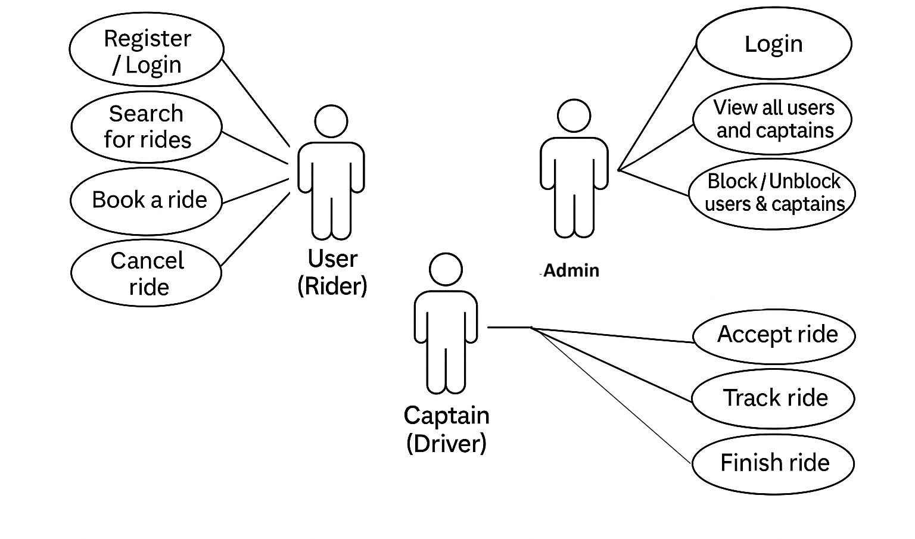

- Data Flow Diagram (DFD)
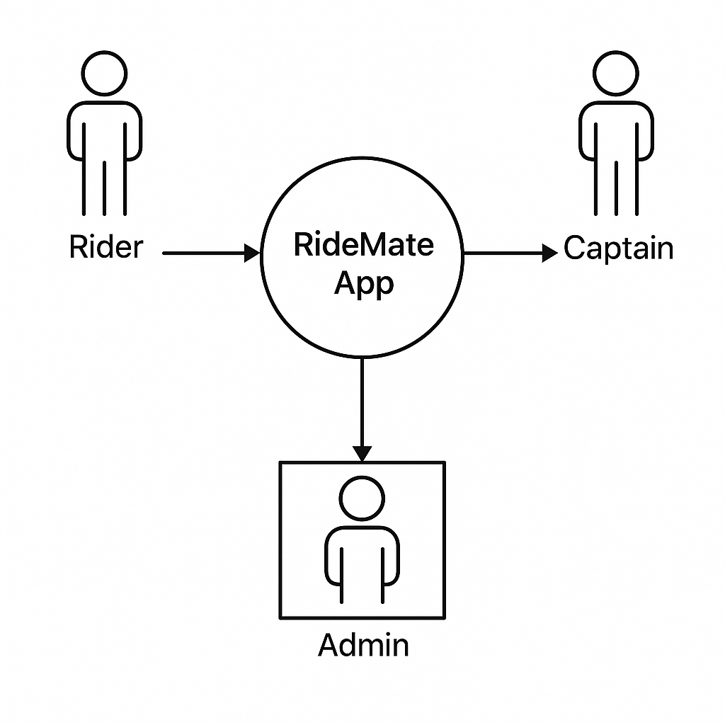

- Entity Relationship (ER) Diagram

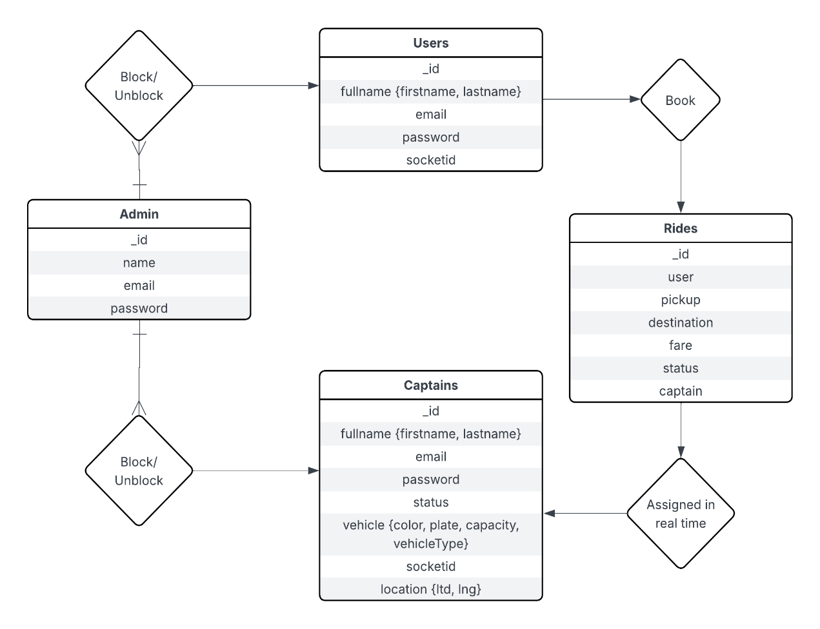

System Design
Modularization Details
The project consists of following modules:
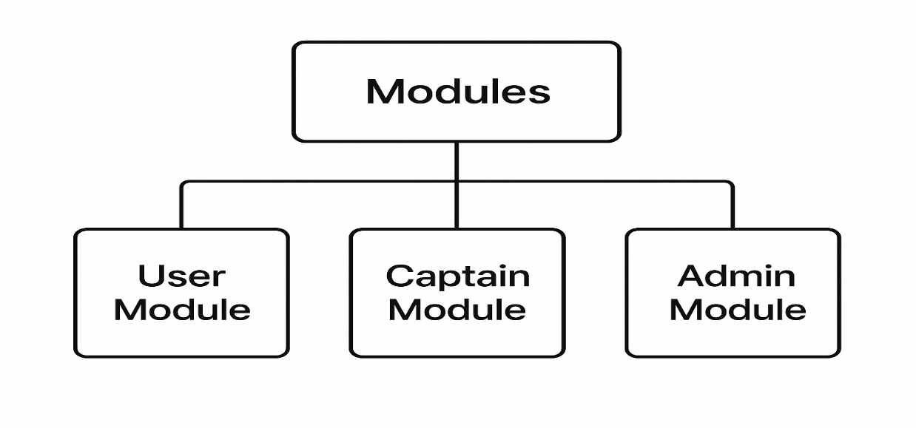

Database Design
Database Design is the process of organizing data into structured tables and defining relationships between them to ensure efficient storage, retrieval, and management of data. It involves creating a logical and physical model of the database to ensure data integrity, minimize redundancy, and support application requirements.

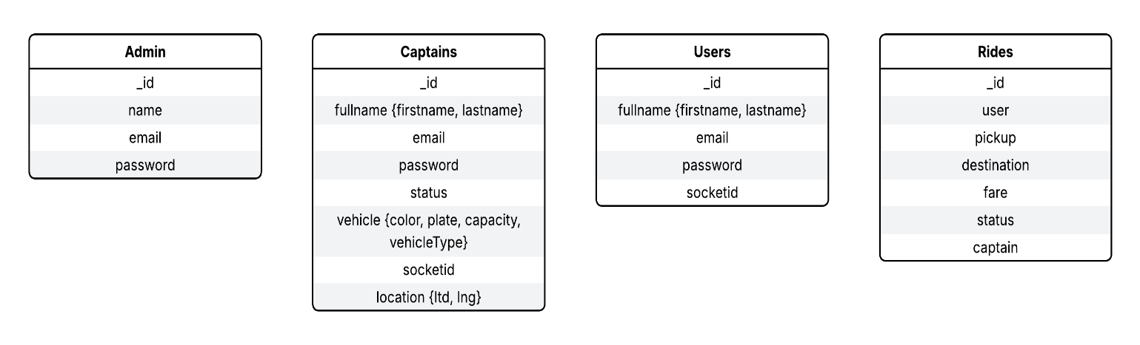

Models

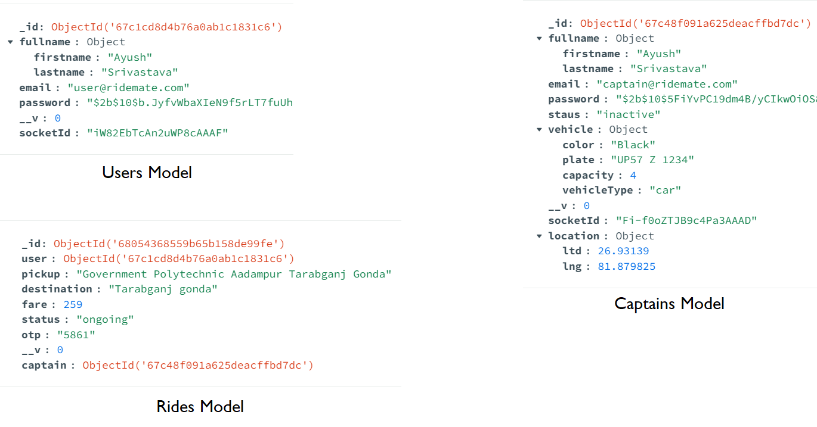

User Interface (UI) Design)
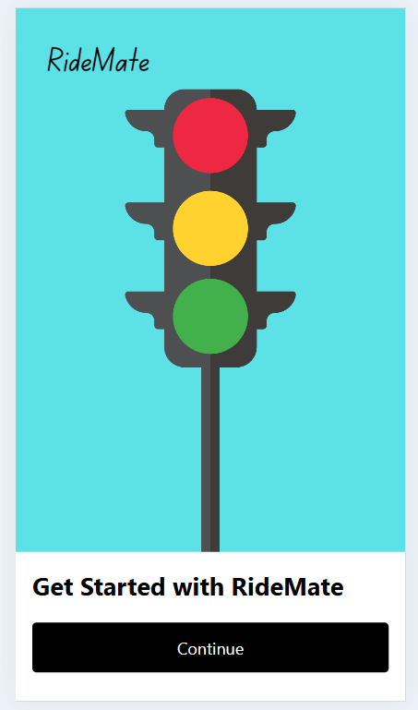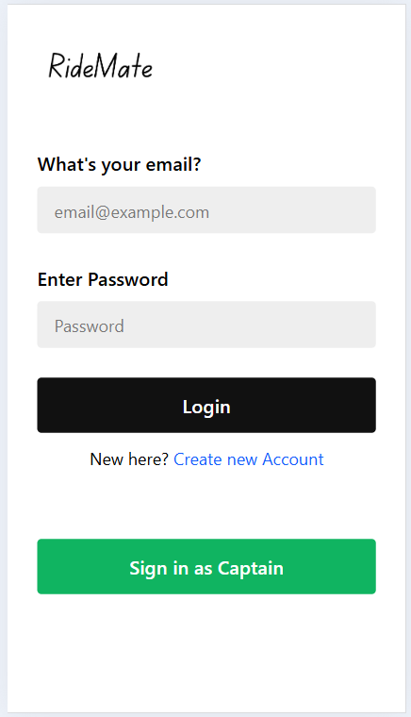
Home User Login

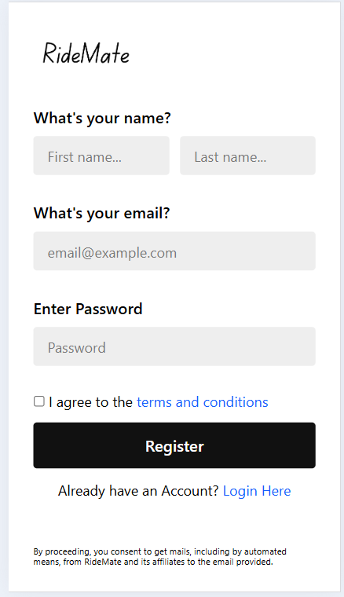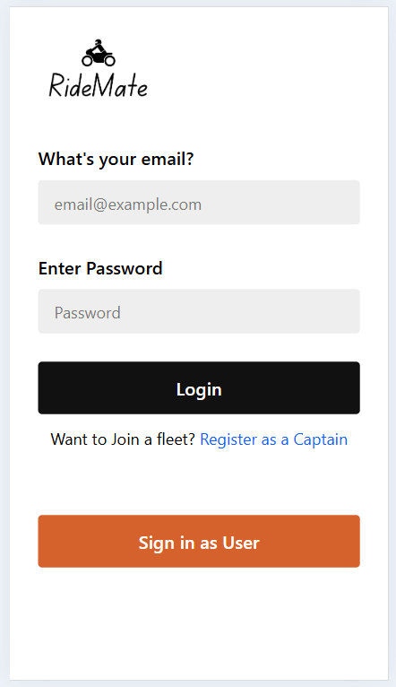
User Register Captain Login
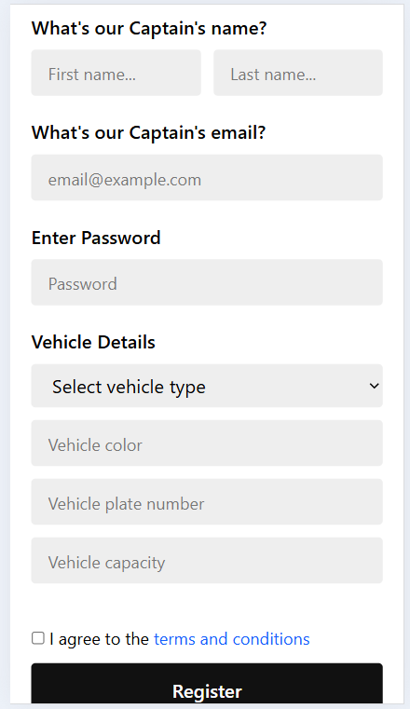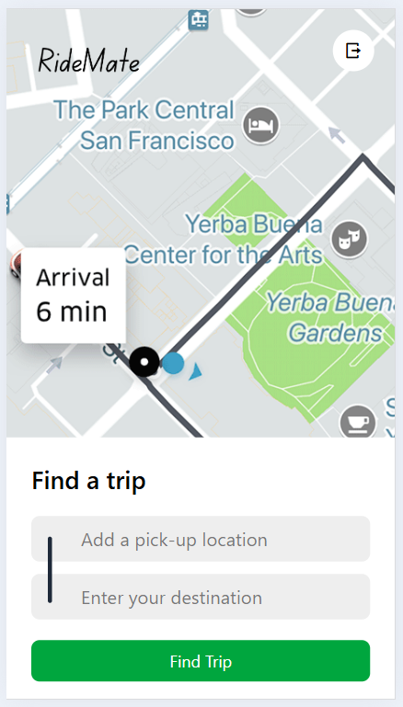
Captain Register User Home

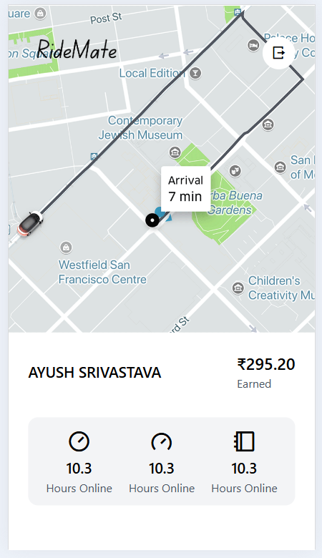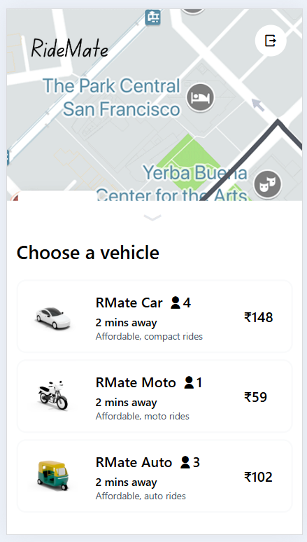
Captain Home User Select Vehicle

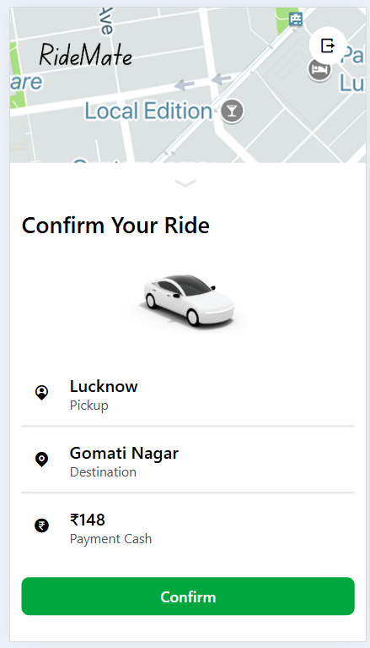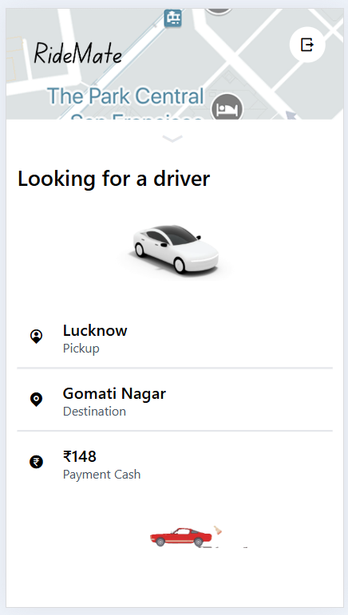
User Confirm Ride User Waiting for Captain

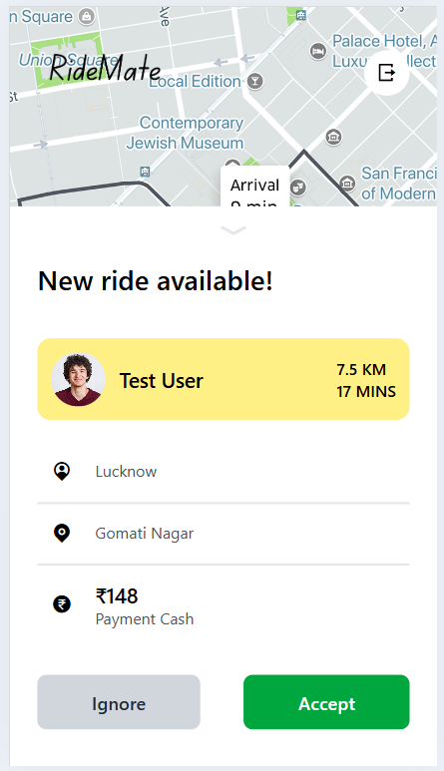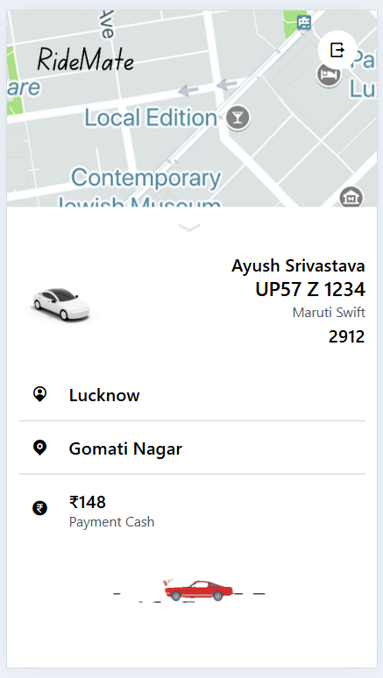
Captain Ride Request User Ride Accepted
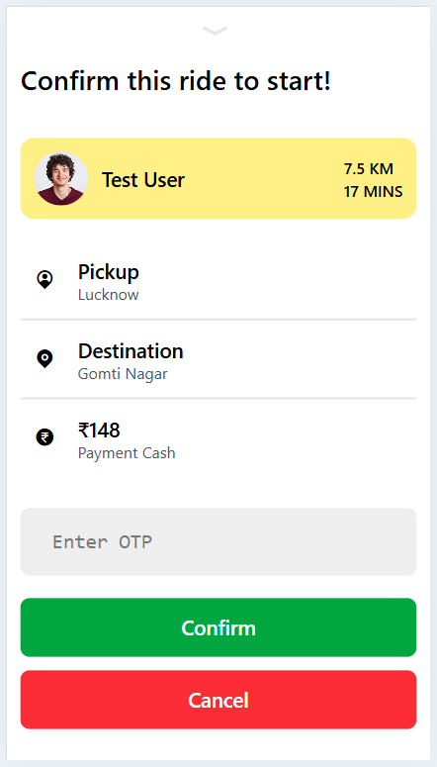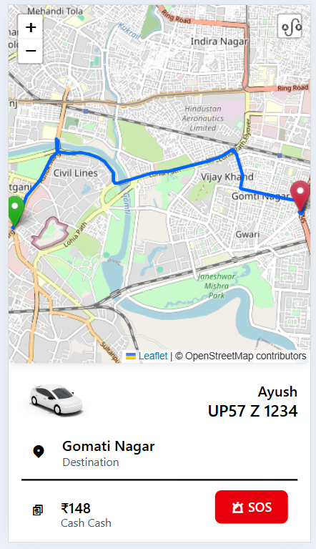
Captain Ride Confirm User Riding

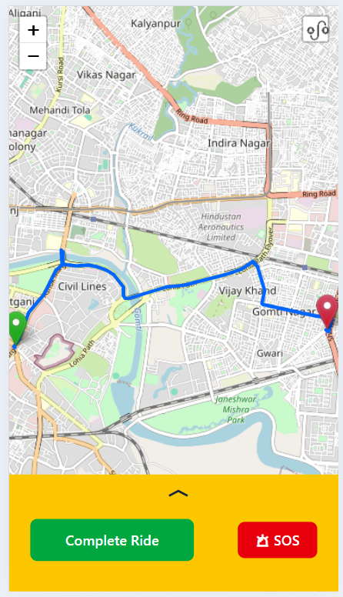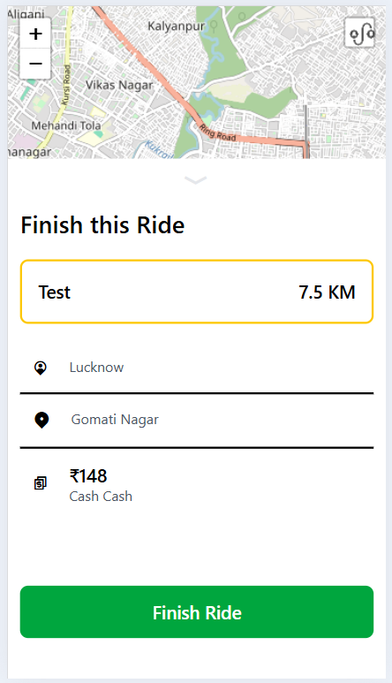
Captain Riding Captain Finish Ride

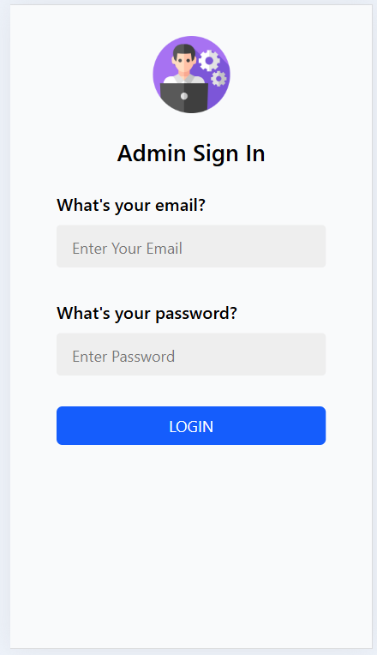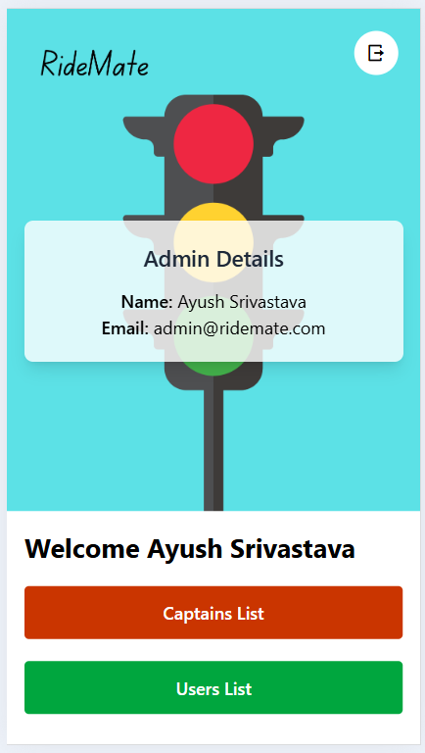
Admin Login Admin Home
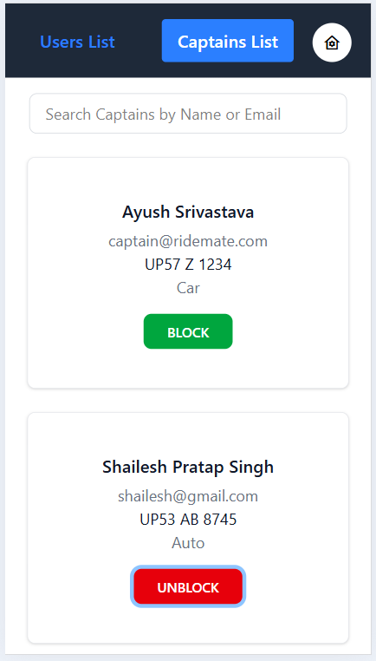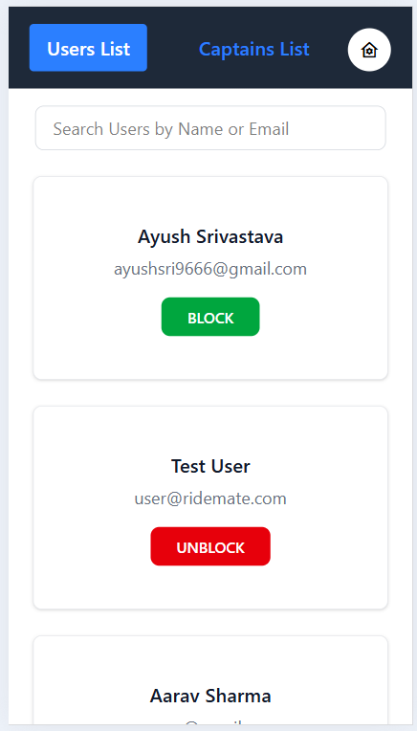
Admin Captains List Admin Users List

PROGRAM CODE
Front- End :-
Home.jsx:-
import React, { useContext, useEffect, useRef, useState } from 'react'
import { useGSAP } from '@gsap/react'
import gsap from 'gsap';
import 'remixicon/fonts/remixicon.css'
import LocationSearchPanel from '../components/LocationSearchPanel';
import VehiclePanel from '../components/VehiclePanel';
import ConfirmRide from '../components/ConfirmRide';
import LookingForDriver from '../components/LookingForDriver';
import WaitingForDriver from '../components/WaitingForDriver';
import axios from 'axios';
import { SocketContext } from '../context/SocketContext';
import { UserDataContext } from '../context/userContext';
import { useNavigate } from 'react-router-dom';
const Home = () => {
const [pickup, setPickup] = useState('');
const [destination, setDestination] = useState('');
const [panelOpen, setPanelOpen] = useState(false);
const panelRef = useRef(null);
const panelCloseRef = useRef(null);
const vehiclePanelRef = useRef(null);
const confirmRidePanelRef = useRef(null);
const vehicleFoundRef = useRef(null);
const WaitingForDriverRef = useRef(null);
const [vehiclePanel, setVehiclePanel] = useState(false);
const [confirmRidePanel, setConfirmRidePanel] = useState(false);
const [vehicleFound, setVehicleFound] = useState(false);
const [waitingForDriver, setWaitingForDriver] = useState(false);
const [pickupSuggestions, setPickupSuggestions] = useState([]);
const [destinationSuggestions, setDestinationSuggestions] = useState([]);
const [activeField, setActiveField] = useState(null);
const [fare, setFare] = useState(null);
const [vehicleType, setVehicleType] = useState(null);
const {socket} = useContext(SocketContext);
const { user } = useContext(UserDataContext);
const [ ride, setRide ] = useState(null)
const navigate = useNavigate();
useEffect(() => {
socket.emit('join', { userId: user._id, userType: 'user' });
} , [])
// console.log("user", user);
socket.on('ride-confirmed', ride => {
setVehicleFound(false)
setWaitingForDriver(true)
setRide(ride)
})
socket.on('ride-started', ride => {
console.log("ride")
setWaitingForDriver(false)
navigate('/riding', { state: { ride } })
})
const handlePickupChange = async (e) => {
setPickup(e.target.value);
try {
const response = await axios.get(`${import.meta.env.VITE_BASE_URL}/maps/get-suggestions`, {
params: { input: e.target.value },
headers: {
Authorization: `Bearer ${localStorage.getItem('token')}`
}
});
if (Array.isArray(response.data)) {
setPickupSuggestions(response.data);
} else {
setPickupSuggestions([]); // Handle unexpected response structure
}
} catch (error) {
console.error('Error fetching suggestions:', error);
}
}
const handleDestinationChange = async (e) => {
setDestination(e.target.value);
try {
const response = await axios.get(`${import.meta.env.VITE_BASE_URL}/maps/get-suggestions`, {
params: { input: e.target.value },
headers: {
Authorization: `Bearer ${localStorage.getItem('token')}`
}
});
setDestinationSuggestions(response.data);
} catch (error) {
console.error('Error fetching suggestions:', error);
}
}
const submitHandler = (e) => {
e.preventDefault();
}
async function findTrip() {
setVehiclePanel(true)
setPanelOpen(false)
const response = await axios.post(`${import.meta.env.VITE_BASE_URL}/rides/get-fare`, { pickup, destination },
{
headers: {
Authorization: `Bearer ${localStorage.getItem('token')}`
}
});
setFare(response.data);
console.log(response.data)
};
async function createRide() {
const response = await axios.post(`${import.meta.env.VITE_BASE_URL}/rides/create`, {
pickup,
destination,
vehicleType
}, {
headers: {
Authorization: `Bearer ${localStorage.getItem('token')}`
}
})
.then(response => {
console.log("Ride created successfully", response.data);
})
.catch(error => {
console.error("Error creating ride:", error);
});
}
useGSAP(() => {
if (panelRef.current) {
gsap.to(panelRef.current, {
height: panelOpen ? '70%' : '0%',
opacity: panelOpen ? 1 : 0,
padding: panelOpen ? 24 : 0,
duration: 0.5,
});
gsap.to(panelCloseRef.current, {
opacity: panelOpen ? 1 : 0,
duration: 0.5
});
}
}, [panelOpen])
useGSAP(() => {
if (vehiclePanel) {
gsap.to(vehiclePanelRef.current, {
transform: 'translateY(0)'
})
}
else {
gsap.to(vehiclePanelRef.current, {
transform: 'translateY(100%)'
})
}
}, [vehiclePanel])

useGSAP(() => {
if (confirmRidePanel) {
gsap.to(confirmRidePanelRef.current, {
transform: 'translateY(0)'
})
}
else {
gsap.to(confirmRidePanelRef.current, {
transform: 'translateY(100%)'
})
}
}, [confirmRidePanel])

useGSAP(() => {
if (vehicleFound) {
gsap.to(vehicleFoundRef.current, {
transform: 'translateY(0)'
})
}
else {
gsap.to(vehicleFoundRef.current, {
transform: 'translateY(100%)'
})
}
}, [vehicleFound])

useGSAP(() => {
if (waitingForDriver) {
gsap.to(WaitingForDriverRef.current, {
transform: 'translateY(0)'
})
}
else {
gsap.to(WaitingForDriverRef.current, {
transform: 'translateY(100%)'
})
}
}, [waitingForDriver])
return (
<div className='h-screen relative'>
<img className='w-30 absolute left-5 top-5' src="Images/RideMate.png" alt="" />
<div className='h-screen w-screen'>
{/* image for temp use */}
<img className='h-full w-full object-cover' src="Images/Homemap.gif" alt="" />
</div>
<div className='flex flex-col justify-end h-screen top-0 absolute w-full'>
<div className='h-[38%] p-6 bg-white relative'>
<h5 className='absolute top-6 right-6 text-2xl opacity-0'
ref={panelCloseRef}
onClick={() => {
setPanelOpen(false)
}}
>
<i className="ri-arrow-down-wide-line"></i>
</h5>
<h4 className='text-2xl font-semibold'>Find a trip</h4>
<form onSubmit={(e) => {
submitHandler(e);
}}>
<div className="line absolute h-16 w-1 top-[38%] left-10 bg-gray-800 rounded-full"></div>
<input
className='bg-[#eee] px-12 py-2 text-lg rounded-lg w-full mt-5'
type="text" placeholder='Add a pick-up location'
onClick={() => {
setPanelOpen(true);
setActiveField('pickup');
}}
value={pickup}
onChange={handlePickupChange}
/>
<input
className='bg-[#eee] px-12 py-2 text-lg rounded-lg w-full mt-3'
type="text" placeholder='Enter your destination'
onClick={() => {
setPanelOpen(true);
setActiveField('destination');
}}
value={destination}
onChange={handleDestinationChange}

/>
</form>
<button
onClick={findTrip}
className='w-full bg-green-600 text-white py-2 rounded-lg my-5'>Find Trip</button>
</div>
{/* Location Panel */}
<div ref={panelRef} className='h-0 bg-white opacity-0 overflow-hidden pb-5'>
<LocationSearchPanel
setVehiclePanel={setVehiclePanel}
setPanelOpen={setPanelOpen}
activeField={activeField}
suggestions={activeField === 'pickup' ? pickupSuggestions : destinationSuggestions}
setDestination={setDestination}
setPickup={setPickup}
/>
</div>
</div>
{/* Vehicle Panel */}
<div ref={vehiclePanelRef} className='fixed w-full z-10 bottom-0 px-3 pb-5 pt-12 bg-white translate-y-full'>
<VehiclePanel
fare={fare}
selectVehicle={setVehicleType}
setVehiclePanel={setVehiclePanel}
setConfirmRidePanel={setConfirmRidePanel} />
</div>
{/* Confirm Ride */}
<div ref={confirmRidePanelRef} className='fixed w-full z-10 bottom-0 px-3 pb-5 pt-12 bg-white translate-y-full'>
<ConfirmRide
createRide={createRide}
pickup={pickup}
destination={destination}
fare={fare}
vehicleType={vehicleType}
setConfirmRidePanel={setConfirmRidePanel}
setVehicleFound={setVehicleFound} />
</div>
{/* Waiting for ride */}
<div ref={vehicleFoundRef} className='fixed w-full z-10 bottom-0 px-3 pb-5 pt-12 bg-white translate-y-full'>
<LookingForDriver
setVehicleFound={setVehicleFound}
createRide={createRide}
pickup={pickup}
destination={destination}
fare={fare}
vehicleType={vehicleType}
/>
</div>
{/* Waiting for driver */}
<div ref={WaitingForDriverRef} className='fixed w-full z-10 bottom-0 px-3 pb-5 pt-12 bg-white'>
<WaitingForDriver
ride={ride}
setVehicleFound={setVehicleFound}
setWaitingForDriver={setWaitingForDriver}
waitingForDriver={waitingForDriver} />
</div>
</div>
)
}
export default Home
App.jsx:-
import React from 'react'
import { Route, Routes } from 'react-router-dom'
import Home from './pages/Home'
import UserLogin from './pages/UserLogin'
import UserSignUp from './pages/UserSignUp'
import CaptainLogin from './pages/CaptainLogin'
import CaptainSignUp from './pages/CaptainSignUp'
import Start from './pages/Start'
import UserProtectedWrapper from './pages/UserProtectedWrapper'
import UserLogout from './pages/UserLogout'
import CaptainHome from './pages/CaptainHome'
import CaptainProtectedWrapper from './pages/CaptainProtectedWrapper'
import CaptainLogout from './pages/CaptainLogout'
import Riding from './pages/Riding'
import CaptainRiding from './pages/CaptainRiding'
import 'leaflet/dist/leaflet.css';
import 'leaflet-routing-machine/dist/leaflet-routing-machine.css';
const App = () => {
return (
<div>
<Routes>
{/* Public Routes */}
<Route path='/' element={<Start/>}/>
<Route path='/login' element={<UserLogin/>}/>
<Route path='/signup' element={<UserSignUp/>}/>
<Route path='/captain-login' element={<CaptainLogin/>}/>
<Route path='/captain-signup' element={<CaptainSignUp/>}/>
{/* User Routes */}
<Route path='/home' element={
<UserProtectedWrapper>
<Home/>
</UserProtectedWrapper>}/>
<Route path='users/logout' element={
<UserProtectedWrapper>
<UserLogout/>
</UserProtectedWrapper>}/>
{/* Captain Routes */}
<Route path='riding' element={
<UserProtectedWrapper>
<Riding/>
</UserProtectedWrapper>
}
<Route path='/captain-home' element={
<CaptainProtectedWrapper>
<CaptainHome/>
</CaptainProtectedWrapper>
}/>
<Route path='/captains/logout' element={
<CaptainProtectedWrapper>
<CaptainLogout/>
</CaptainProtectedWrapper>
}/>
<Route path='/captain-riding' element={
<CaptainProtectedWrapper>
<CaptainRiding/>
</CaptainProtectedWrapper>
}/>
</Routes>
</div>
)
}
export default App
main.jsx:-
import { StrictMode } from 'react'
import { createRoot } from 'react-dom/client'
import './index.css'
import App from './App.jsx'
import { BrowserRouter } from 'react-router-dom';
import UserContext from './context/UserContext.jsx';
import CaptainContext from './context/CaptainContext.jsx';
import SocketProvider from './context/SocketContext.jsx';
createRoot(document.getElementById('root')).render(
<CaptainContext>
<UserContext>
<SocketProvider>
<BrowserRouter>
<App />
</BrowserRouter>
</SocketProvider>
</UserContext>
</CaptainContext>
)

CaptainContext.jsx:-
import React, { createContext, useState } from 'react';
export const CaptainDataContext = createContext();
const CaptainContext = ({ children }) => {
const [captain, setCaptain] = useState({});
const [isLoading, setIsLoading] = useState(false);
const [error, setError] = useState(null);
const updateCaptain = (captainData) =>{
setCaptain(captainData);
}
const values = {
captain,
setCaptain,
isLoading,
setIsLoading,
error,
setError,
updateCaptain
}
return (
<CaptainDataContext.Provider value={values}>
{children}
</CaptainDataContext.Provider>
);
};
export default CaptainContext
CaptainHome.jsx:-
import React, { useContext, useRef, useState, useEffect } from 'react'
import { Link } from 'react-router-dom'
import CaptainDetails from '../components/CaptainDetails'
import RidePopUp from '../components/RidePopUp'
import { useGSAP } from '@gsap/react'
import gsap from 'gsap'
import ConfirmRidePopUp from '../components/ConfirmRidePopUp'
import { CaptainDataContext } from '../context/CaptainContext'
import { SocketContext } from '../context/SocketContext'
import axios from 'axios'
const CaptainHome = () => {
const { captain } = useContext(CaptainDataContext);
const { socket } = useContext(SocketContext);
const [ridePopUpPanel, setRidePopUpPanel] = useState(false);
const ridePopUpPanelRef = useRef(null);
const [confirmRidePopUpPanel, setConfirmRidePopUpPanel] = useState(false);
const confirmRidePopUpPanelRef = useRef(null);
const [ride, setRide] = useState(null);
useEffect(() => {
socket.emit('join', {userId: captain._id,userType: 'captain' })
const updateLocation = () => {
if (navigator.geolocation) {
navigator.geolocation.getCurrentPosition(position => {
socket.emit('update-location-captain', {
userId: captain._id,
location: {
ltd: position.coords.latitude,
lng: position.coords.longitude
}
})
})
}
}
const locationInterval = setInterval(updateLocation, 10000)
updateLocation()
}, [])

socket.on('new-ride', (data) => {
setRide(data);
setRidePopUpPanel(true);
})
async function confirmRide() {
const response = await axios.post(`${import.meta.env.VITE_BASE_URL}/rides/confirm`, {
rideId: ride._id,
captainId: captain._id,
}, {
headers: {
Authorization: `Bearer ${localStorage.getItem('token')}`
}
})
setRidePopUpPanel(false)
setConfirmRidePopUpPanel(true)

}
useGSAP(() => {
if (ridePopUpPanel) {
gsap.to(ridePopUpPanelRef.current, {
transform: 'translateY(0)'
})
}
else {
gsap.to(ridePopUpPanelRef.current, {
transform: 'translateY(100%)'
})
}
}, [ridePopUpPanel])
useGSAP(() => {
if (confirmRidePopUpPanel) {
gsap.to(confirmRidePopUpPanelRef.current, {
transform: 'translateY(0)'
})
}
else {
gsap.to(confirmRidePopUpPanelRef.current, {
transform: 'translateY(100%)'
})
}
}, [confirmRidePopUpPanel])
return (
<div className='h-screen'>
<div className='flex justify-between p-6 w-full fixed items-center top-0'>
<div>
<img className='w-30' src="Images/RideMate.png" alt="" />
</div>
<div>
<Link to='/captains/logout' className='flex bg-white h-10 justify-center rounded-full w-10 items-center'>
<i className="text-lg font-medium ri-logout-box-r-line"></i>
</Link>
</div>
</div>
<div className='h-3/5'>
<img className='h-full w-full object-cover' src="Images/Homemap.gif" alt="" />
</div>
<div className='h-2/5 p-6'>
<CaptainDetails />
</div>
{/* Ride Pop Up */}
<div ref={ridePopUpPanelRef} className='bg-white w-full bottom-0 fixed pb-5 pt-12 px-3 translate-y-full z-10'>
<RidePopUp
ride={ride}
setRidePopUpPanel={setRidePopUpPanel}
setConfirmRidePopUpPanel={setConfirmRidePopUpPanel}
confirmRide={confirmRide}
/>
</div>
{/* User's Details */}
<div ref={confirmRidePopUpPanelRef} className='bg-white h-screen w-full bottom-0 fixed pb-5 pt-12 px-3 translate-y-full z-10'>
<ConfirmRidePopUp
ride={ride}
setConfirmRidePopUpPanel={setConfirmRidePopUpPanel} setRidePopUpPanel={setRidePopUpPanel}/>
</div>
</div>
)
}
export default CaptainHome
CaptainLogin:-
import React, { useContext, useState, useEffect } from 'react';
import { Link, useNavigate } from 'react-router-dom';
import axios from 'axios';
import { CaptainDataContext } from '../context/CaptainContext';
const CaptainLogin = () => {
const [email, setEmail] = useState('');
const [password, setPassword] = useState('');
const { captain, setCaptain } = useContext(CaptainDataContext);
const navigate = useNavigate();
const submitHandler = async (e) => {
e.preventDefault();
const captaindets = {
email: email,
password: password
};
const response = await axios.post(`${import.meta.env.VITE_BASE_URL}/captains/login`, captaindets);
if (response.status === 200) {
const data = response.data;
setCaptain(data.captain); // Update the captain state
console.log(data.captain);

localStorage.setItem('token', data.token);
navigate('/captain-home');
}

setEmail('');
setPassword('');
};

return (
<div className='flex flex-col h-screen justify-between p-7'>
<div>
<img src="../public/images/RideMateCaptain.png" className='w-30 mb-10' />
<form onSubmit={submitHandler}>
<h3 className='text-lg font-medium mb-2'>What's your email?</h3>
<input
type="email"
value={email}
onChange={(e) => setEmail(e.target.value)}
required
className='bg-[#eeeeee] rounded text-lg w-full mb-7 placeholder:text-base px-4 py-2'
placeholder='email@example.com'
/>
<h3 className='text-lg font-medium mb-2'>Enter Password</h3>
<input
type="password"
value={password}
onChange={(e) => setPassword(e.target.value)}
required
className='bg-[#eeeeee] rounded text-lg w-full mb-7 placeholder:text-base px-4 py-2'
placeholder='Password'
/>
<button
className='bg-[#111] rounded text-lg text-white w-full font-semibold mb-3 py-3'
>
Login
</button>
</form>
<p className='text-center'>Want to Join a fleet? <Link to='/captain-signup' className='text-blue-600'> Register as a Captain</Link></p>
</div>
<div>
<Link to='/login'
className='flex bg-[#d5622d] justify-center rounded text-lg text-white w-full font-semibold items-center mb-5 py-3'>
Sign in as User
</Link>
</div>
</div>
);
};
export default CaptainLogin;
CaptainLogout:-
import React, { useEffect } from 'react';
import axios from 'axios';
import { useNavigate } from 'react-router-dom';
const CaptainLogout = () => {
const navigate = useNavigate();
useEffect(() => {
const token = localStorage.getItem('token');
axios.get(`${import.meta.env.VITE_BASE_URL}/captains/logout`, {
headers: { Authorization: `Bearer ${token}` }
})
.then((response) => {
if (response.status === 200) {
localStorage.removeItem('token');
navigate('/captain-login');
}
})
.catch((error) => {
console.error("Logout failed", error);
});
}, []); // Runs only once on mount

return <div>Logging out...</div>;
};

export default CaptainLogout;

CaptainProtectedWrapper:-
import React, { useContext, useEffect, useState } from 'react';
import { useNavigate } from 'react-router-dom';
import { CaptainDataContext } from '../context/CaptainContext';
import axios from 'axios';
const CaptainProtectedWrapper = ({ children }) => {
const token = localStorage.getItem('token');
const navigate = useNavigate();
const { captain, setCaptain } = useContext(CaptainDataContext);
const [isLoading, setIsLoading] = useState(true);
useEffect(() => {
if (!token) {
navigate('/captain-login');
return;
}
axios.get(`${import.meta.env.VITE_BASE_URL}/captains/profile`, {
headers: { Authorization: `bearer ${token}` }
}).then(response => {
if (response.status === 200) {
setCaptain(response.data);
setIsLoading(false);
}
}).catch(() => {
localStorage.removeItem('token');
navigate('/captain-login');
}).finally(() => {
setIsLoading(false);
});
}, [token, navigate, setCaptain]);

if (isLoading) {
return <div>Loading...</div>;
}
return <>{children}</>;
};
export default CaptainProtectedWrapper;
CaptainRiding:-
import React, { useEffect, useRef, useState } from 'react'
import { Link, useLocation, useNavigate } from 'react-router-dom'
import FinishRide from '../components/FinishRide'
import { useGSAP } from '@gsap/react'
import gsap from 'gsap'
import LiveTracking from '../components/LiveTracking'
import axios from 'axios'
import './map.css'
const CaptainRiding = () => {
const location = useLocation()
const { ride } = location.state || {}
console.log(ride);
const [ finishRidePanel, setFinishRidePanel ] = useState(false)
const finishRidePanelRef = useRef(null)
const rideData = location.state?.ride
const [pointA, setPointA] = useState(null);
const [pointB, setPointB] = useState(null);
const [error, setError] = useState(null);
const pickup = ride.pickup;
const destination = ride.destination;
const token = localStorage.getItem('token');
const fetchCoordinatesA = async () => {
try {
const response = await axios.get(`http://localhost:4000/maps/get-coordinate`, {
params: { address: pickup },
headers: {
Authorization: `Bearer ${token}` // pass the token in headers
}
});
setPointA(response.data);
setError(null);
} catch (err) {
console.error(err);
setError('Failed to fetch coordinates');
}
};
const fetchCoordinatesB = async () => {
try {
const response = await axios.get(`http://localhost:4000/maps/get-coordinate`, {
params: { address: destination },
headers: {
Authorization: `Bearer ${token}` // pass the token in headers
}
});
setPointB(response.data);
setError(null);
} catch (err) {
console.error(err);
setError('Failed to fetch coordinates');
}
};
useEffect(() => {
fetchCoordinatesA();
fetchCoordinatesB();
}, []);
useGSAP(() => {
gsap.to(finishRidePanelRef.current, {
transform: finishRidePanel ? 'translateY(0%)' : 'translateY(100%)',
duration: 0.5,
ease: 'power3.out'
});
}, [finishRidePanel]);
return (
<div className='h-screen relative flex flex-col justify-end z-0'>
<div className='fixed p-6 top-0 flex items-center justify-between w-screen'>
<img className='w-16' src="Images/RideMate.png" alt="" />
<Link to='/captain-home' className=' h-10 w-10 bg-white flex items-center justify-center rounded-full'>
<i className="text-lg font-medium ri-logout-box-r-line"></i>
</Link>
</div>
<div className='h-1/5 p-6 flex items-center justify-between relative bg-yellow-400 pt-10 z-50'
onClick={() => {
setFinishRidePanel(true)
}}
>
<h5 className='p-1 text-center w-[90%] absolute top-0' onClick={() => {
}}><i className="text-3xl text-gray-800 ri-arrow-up-wide-line"></i></h5>
<h4 className='text-xl font-semibold'>{'4 KM away'}</h4>
<button className=' bg-green-600 text-white font-semibold p-3 px-10 rounded-lg'>Complete Ride</button>
</div>
<div ref={finishRidePanelRef} className='fixed w-full z-50 bottom-0 bg-white px-3 py-10 pt-12'
style={{ transform: 'translateY(100%)' }}
>
<FinishRide
ride={rideData}
setFinishRidePanel={setFinishRidePanel} />
</div>
<div className='h-full fixed w-screen top-0 z-0'>
<LiveTracking pointA={pointA} pointB={pointB} />
</div>
</div>
)
}
export default CaptainRiding

CaptainDetails:-
import React, { useContext } from 'react'
import { CaptainDataContext } from '../context/CaptainContext';
const CaptainDetails = () => {
const {captain} = useContext(CaptainDataContext);
console.log(captain);
if (!captain) {
return <div>Loading captain data...</div>;
}
return (
<div>
<div className='flex justify-between items-center'>
<div className='flex justify-start gap-3 items-center'>
<img src="\Images\driver.jpg" alt="" className='h-10 rounded-full w-10 object-cover' />
<h4 className='text-lg font-medium uppercase'>{captain?.fullname?.firstname + ' ' + captain?.fullname?.lastname || 'Please log in'}</h4>
</div>
<div>
<h4 className='text-xl font-semibold'>₹295.20</h4>
<p className='text-gray-600 text-sm'>Earned</p>
</div>
</div>
<div className='flex bg-gray-100 justify-center p-3 rounded-xl gap-5 items-start mt-8'>
<div className='text-center'>
<i className="text-3xl font-extralight mb-2 ri-timer-2-line"></i>
<h5 className='text-lg font-medium'>10.3</h5>
<p className='text-gray-600 text-sm'>Hours Online</p>
</div>
<div className='text-center'>
<i className="text-3xl font-extralight ri-speed-up-line"></i>
<h5 className='text-lg font-medium'>10.3</h5>
<p className='text-gray-600 text-sm'>Hours Online</p>
</div>
<div className='text-center'>
<i className="text-3xl font-extralight ri-booklet-line"></i>
<h5 className='text-lg font-medium'>10.3</h5>
<p className='text-gray-600 text-sm'>Hours Online</p>
</div>
</div>
</div>
)
}
export default CaptainDetails

ConfirmRide:-
import React from 'react'
const ConfirmRide = (props) => {
return (
<div>
<h5 onClick={() => {
props.setConfirmRidePanel(false)
}} className='p-1 text-center absolute top-0 w-[92%]'><i className="text-3xl text-gray-200 ri-arrow-down-wide-line"></i></h5>
<h3 className='text-2xl font-semibold mb-5'>Confirm Your Ride</h3>
<div className='flex flex-col gap-2 justify-between items-center'>
<img src="Images/car.webp" alt="" className='h-20' />
<div className='w-full mt-5'>
<div className='flex items-center gap-5 p-3 border-b-2 border-gray-200'>
<i className="text-lg ri-map-pin-user-fill"></i>
<div>
<h3 className='text-lg font-medium'>{props.pickup}</h3>
<p className='text-sm -mt-1 text-gray-600'>Pickup</p>
</div>
</div>
<div className='flex items-center gap-5 p-3 border-b-2 border-gray-200'>
<i className="text-lg ri-map-pin-fill"></i>
<div>
<h3 className='text-lg font-medium'>{props.destination}</h3>
<p className='text-sm -mt-1 text-gray-600'>Destination</p>
</div>
</div>
<div className='flex items-center gap-5 p-3'>
<i className="text-lg ri-money-rupee-circle-fill"></i>
<div>
<h3 className='text-lg font-medium'>₹{props.fare?.[props.vehicleType] ?? "N/A"}</h3>
<p className='text-sm -mt-1 text-gray-600'>Payment Cash</p>
</div>
</div>
</div>
<button onClick={()=>{
props.createRide()
props.setVehicleFound(true)
props.setConfirmRidePanel(false)
}} className='w-full mt-5 bg-green-600 text-white font-semibold p-2 rounded-lg'>Confirm</button>
</div>
</div>
)
}
export default ConfirmRide
ConfirmRidePopUp:-
import React, { useState } from 'react'
import axios from 'axios';
import { useNavigate } from 'react-router-dom';
const ConfirmRidePopUp = (props) => {
const navigate = useNavigate();
const [otp, setOtp] = useState('')
const submitHandler = async (e) => {
e.preventDefault()
const response = await axios.get(`${import.meta.env.VITE_BASE_URL}/rides/start-ride`, {
params: {
rideId: props.ride._id,
otp: otp
},
headers: {
Authorization: `Bearer ${localStorage.getItem('token')}`
}
})
if (response.status === 200) {
props.setConfirmRidePopUpPanel(false)
props.setRidePopUpPanel(false)
navigate('/captain-riding', { state: { ride: props.ride } })
}
}
return (
<div>
<h5 onClick={() => {
props.setRidePopUpPanel(false)
}} className='p-1 text-center absolute top-0 w-[92%]'><i className="text-3xl text-gray-200 ri-arrow-down-wide-line"></i></h5>
<h3 className='text-2xl font-semibold mb-9'>Confirm this ride to start!</h3>
<div className='flex items-center justify-between p-3 bg-yellow-200 rounded-xl'>
<div className='flex items-center gap-3'>
<img src="/Images/user.avif" alt="" className='w-12 h-12 rounded-full object-cover' />
<h2 className='text-lg font-medium'>{props.ride?.user.fullname.firstname + " " + props.ride?.user.fullname.lastname}</h2>
</div>
<h5 className='text-lg font-semibold'>2.2 KM</h5>
</div>
<div className='flex flex-col gap-2 justify-between items-center'>
<div className='w-full mt-5'>
<div className='flex items-center gap-5 p-3 border-b-2 border-gray-200'>
<i className="text-lg ri-map-pin-user-fill"></i>
<div>
<h3 className='text-lg font-medium'>Pickup</h3>
<p className='text-sm -mt-1 text-gray-600'>{props.ride?.pickup}</p>
</div>
</div>
<div className='flex items-center gap-5 p-3 border-b-2 border-gray-200'>
<i className="text-lg ri-map-pin-fill"></i>
<div>
<h3 className='text-lg font-medium'>Destination</h3>
<p className='text-sm -mt-1 text-gray-600'>{props.ride?.destination}</p>
</div>
</div>
<div className='flex items-center gap-5 p-3'>
<i className="text-lg ri-money-rupee-circle-fill"></i>
<div>
<h3 className='text-lg font-medium'>₹{props.ride?.fare}</h3>
<p className='text-sm -mt-1 text-gray-600'>Payment Cash</p>
</div>
</div>
</div>
<div className='w-full'>
<form onSubmit={submitHandler}>
<input value={otp} type="text" placeholder="Enter OTP" className='bg-[#eee] px-7 py-4 text-lg font-mono rounded-lg w-full mt-5'
onChange={(e)=>{
setOtp(e.target.value);
}}
/>
<button className='w-full flex justify-center mt-5 bg-green-600 text-white font-semibold p-3 rounded-lg mb-2 text-lg'>Confirm
</button>
<button onClick={() => {
props.setConfirmRidePopupPanel(false)
props.setRidePopupPanel(false)
}} className='w-full mt-1 bg-red-500 text-white font-semibold p-3 rounded-lg text-lg'>Cancel
</button>
</form>
</div>
</div>
</div>
)
}

export default ConfirmRidePopUp
FinishRide:-
import React from 'react'
import { Link } from 'react-router-dom'
import axios from 'axios'
import { useNavigate } from 'react-router-dom'
const FinishRide = (props) => {
const navigate = useNavigate()
async function endRide() {
const response = await axios.post(`${import.meta.env.VITE_BASE_URL}/rides/end-ride`, {
rideId: props.ride._id
}, {
headers: {
Authorization: `Bearer ${localStorage.getItem('token')}`
}
})
if (response.status === 200) {
navigate('/captain-home')
}
}
return (
<div>
<h5 className='p-1 text-center w-[93%] absolute top-0' onClick={() => {
props.setFinishRidePanel(false)
}}><i className="text-3xl text-gray-200 ri-arrow-down-wide-line"></i></h5>
<h3 className='text-2xl font-semibold mb-5'>Finish this Ride</h3>
<div className='flex items-center justify-between p-4 border-2 border-yellow-400 rounded-lg mt-4'>
<div className='flex items-center gap-3 '>
<img className='h-12 rounded-full object-cover w-12' src="https://i.pinimg.com/236x/af/26/28/af26280b0ca305be47df0b799ed1b12b.jpg" alt="" />
<h2 className='text-lg font-medium'>{props.ride?.user.fullname.firstname}</h2>
</div>
<h5 className='text-lg font-semibold'>2.2 KM</h5>
</div>
<div className='flex gap-2 justify-between flex-col items-center'>
<div className='w-full mt-5'>
<div className='flex items-center gap-5 p-3 border-b-2'>
<i className="ri-map-pin-user-fill"></i>
<div>
<h3 className='text-lg font-medium'>562/11-A</h3>
<p className='text-sm -mt-1 text-gray-600'>{props.ride?.pickup}</p>
</div>
</div>
<div className='flex items-center gap-5 p-3 border-b-2'>
<i className="text-lg ri-map-pin-2-fill"></i>
<div>
<h3 className='text-lg font-medium'>562/11-A</h3>
<p className='text-sm -mt-1 text-gray-600'>{props.ride?.destination}</p>
</div>
</div>
<div className='flex items-center gap-5 p-3'>
<i className="ri-currency-line"></i>
<div>
<h3 className='text-lg font-medium'>₹{props.ride?.fare} </h3>
<p className='text-sm -mt-1 text-gray-600'>Cash Cash</p>
</div>
</div>
</div>
<div className='mt-10 w-full'>
<button
onClick={endRide}
className='w-full mt-5 flex text-lg justify-center bg-green-600 text-white font-semibold p-3 rounded-lg'>Finish Ride</button>
</div>
</div>
</div>
)
}
export default FinishRide
LiveTracking:-
import React, { useEffect, useRef } from 'react';
import { MapContainer, TileLayer, useMap } from 'react-leaflet';
import L from 'leaflet';
import 'leaflet/dist/leaflet.css';
import 'leaflet-routing-machine';
import 'leaflet-routing-machine/dist/leaflet-routing-machine.css';
// Fix default marker icons
delete L.Icon.Default.prototype._getIconUrl;
L.Icon.Default.mergeOptions({
iconRetinaUrl: 'https://unpkg.com/leaflet@1.7.1/dist/images/marker-icon-2x.png',
iconUrl: 'https://unpkg.com/leaflet@1.7.1/dist/images/marker-icon.png',
shadowUrl: 'https://unpkg.com/leaflet@1.7.1/dist/images/marker-shadow.png',
});
const RoutingControl = ({ pointA, pointB }) => {
const map = useMap();
useEffect(() => {
if (!pointA || !pointB || !map) return;
const routingControl = L.Routing.control({
waypoints: [
L.latLng(pointA.ltd, pointA.lng),
L.latLng(pointB.ltd, pointB.lng),
],
routeWhileDragging: true,
showAlternatives: true,
addWaypoints: false,
draggableWaypoints: false,
fitSelectedRoutes: true,
lineOptions: {
styles: [{ color: '#0066ff', weight: 4 }],
},
createMarker: function (i, waypoint, n) {
return L.marker(waypoint.latLng, {
icon: L.icon({
iconUrl: i === 0
? 'https://raw.githubusercontent.com/pointhi/leaflet-color-markers/master/img/marker-icon-green.png'
: 'https://raw.githubusercontent.com/pointhi/leaflet-color-markers/master/img/marker-icon-red.png',
shadowUrl: 'https://cdnjs.cloudflare.com/ajax/libs/leaflet/1.7.1/images/marker-shadow.png',
iconSize: [25, 41],
iconAnchor: [12, 41],
popupAnchor: [1, -34],
shadowSize: [41, 41],
}),
title: i === 0 ? 'Start Point' : 'End Point',
}).bindPopup(i === 0 ? 'Start Location' : 'Destination');
},
}).addTo(map);

return () => map.removeControl(routingControl);
}, [map, pointA, pointB]);

return null;
};
const LiveTracking = ({ pointA, pointB }) => {
return (
<MapContainer
center={[pointA?.ltd || 0, pointA?.lng || 0]}
zoom={13}
scrollWheelZoom={true}
className="map-container"
style={{
height: '500px',
width: '100%',
borderRadius: '8px',
boxShadow: '0 2px 10px rgba(0,0,0,0.1)'
}}
>
<TileLayer
attribution='&copy; OpenStreetMap contributors'
url="https://{s}.tile.openstreetmap.org/{z}/{x}/{y}.png"
/>
<RoutingControl pointA={pointA} pointB={pointB} />
</MapContainer>
);
};
export default LiveTracking;
LocationSearchPanel:-
import React from 'react'
const LocationSearchPanel = ({ suggestions, setPickup, setDestination, activeField }) => {
const handleSuggestionClick = (suggestion) => {
if (activeField === 'pickup') {
setPickup(suggestion)
} else if (activeField === 'destination') {
setDestination(suggestion)
}
// setVehiclePanel(true)
// setPanelOpen(false)
}
return (
<div className='h-full overflow-y-scroll'>
{suggestions && suggestions.length > 0 ? (
suggestions.map((elem, idx) => (
<div key={elem.place_id}
onClick={() => handleSuggestionClick(elem.structured_formatting.main_text)}
className='flex gap-4 border-2 p-3 m-0 border-gray-50 active:border-black rounded-xl items-center justify-start'>
<h2 className='bg-[#eee] h-8 flex items-center justify-center rounded-full w-[15%]'>
<i className="ri-map-pin-fill"></i>
</h2>
<div className='block items-center justify-end w-[85%]'>
<h4 className='font-medium'>{elem.structured_formatting.main_text}</h4> <br />
<p className='text-xs text-gray-600 -mt-5'>{elem.structured_formatting.secondary_text}</p>
</div>
</div>
))
) : (
<h4 className='text-gray-500 text-center mt-3'>No suggestions found</h4>
)}
</div>
);
}
export default LocationSearchPanel

TESTING

Software Testing is the process of verifying and validating that the cab booking system functions as intended, meets user requirements, and is free from critical bugs or defects. It ensures system reliability, functionality, and performance before deployment.

- Types of Testing I do in my Project:
- Unit Testing:
Individual components like user registration, ride booking, ride acceptance by captain, and OTP generation are tested separately to ensure they perform as expected.

- Integration Testing:
Verifies interactions between modules, such as:
- Ride booking by user and acceptance by captain
- OTP flow from system to user to captain
- Real-time map tracking between captain and user

- System Testing:
A complete end-to-end test of the entire system — from login, booking, OTP confirmation, to ride completion — ensuring all modules work together smoothly.

- User Acceptance Testing (UAT):
Conducted with sample users (user, captain, and admin) to confirm the system is user-friendly, functional, and ready for real-world use.

- Functional Testing:
Ensures that every function — like booking a ride, blocking a user, verifying OTP, tracking the ride, or finishing the ride — operates correctly as defined in the requirements.

IMPLEMENTATION OF SECURITY

To ensure the confidentiality, integrity, and availability of user, captain, and admin data within the Cab Booking System, the following security features were implemented:

1. User Authentication:
- Only registered users and captains can log in to the system using valid credentials.
- Passwords are securely stored using hashing algorithms (e.g., bcrypt or MD5, based on platform limitations).
- Invalid login attempts are restricted to prevent brute-force attacks.

2. Role-Based Access Control:
- Users, Captains, and Admins can only access modules and pages related to their roles.
- For example, a user cannot access admin dashboard or captain controls.
- Admins have full privileges, including user and captain management.

3. OTP Verification for Ride Start:
- A secure OTP is auto-generated after captain accepts the ride.
- The ride begins only after the captain enters the correct OTP from the user, preventing unauthorized ride starts.

4. Input Validation:
- All input fields (e.g., login, booking form, feedback) are validated to avoid injection attacks and invalid entries.
- Frontend and backend validation ensure proper format and sanitization.

5. Session Handling:
- Logged-in sessions are time-limited and stored securely.
- On logout, sessions are cleared immediately to prevent unauthorized reuse.

6. Map and Location Security:
- Real-time tracking is restricted to authenticated users and captains involved in that specific ride.
- Location data is shared temporarily and not stored permanently beyond the ride session.

7. Basic Error Handling:
- The system avoids displaying technical errors or stack traces directly to users.
- Friendly error messages are shown while actual errors are logged securely for admin review.

LIMITATIONS OF THE PROJECT

- No Payment Gateway Integration
Users cannot pay online; the system supports only ride booking and tracking.
- Lack of Fare Calculation
The application does not display estimated or final ride fare to the user.
- No Ride History Tracking
Past rides are not stored; users and captains cannot view previous trip records.
- Basic Real-Time Tracking
Real-time location tracking depends on third-party APIs and may be inaccurate in poor network zones.
- No Feedback or Rating System
Users and captains cannot provide feedback or rate each other after a ride.
- Limited Admin Analytics
Admin panel does not show advanced statistics like total rides, earnings, or active users.
- No Cancellation Feature
Once a ride is booked and accepted, there is no option to cancel the ride.
- No Emergency or SOS Feature
The system lacks a panic button or emergency contact option for safety concerns.
- Single Language Support
The application currently supports only one language and is not localized for different regions.
- Limited Scalability
The current design is suitable for small-scale use; may need improvements for large-scale deployment.

FUTURE SCOP AND FURTHER ENHANCEMENT

  - Fare Estimation and Billing
Show estimated fare before booking and generate detailed ride invoices after completion.
  - Ride History Module
Maintain logs of past rides for both users and captains, viewable anytime.
  - Rating and Feedback System
Allow users and captains to rate each other and leave feedback after every ride to improve service quality.
  - Multi-Ride Handling
Enable captains to manage multiple ride requests in a queue and users to schedule future rides.
  - Emergency/SOS Feature
Add a panic button during ride that sends location and alert to admin or emergency contacts.
  - Push Notifications
Send real-time updates about ride status, OTP, and captain arrival via app or browser notifications.
  - Advanced Admin Dashboard
Include analytics on rides, active users/captains, earnings, and issue tracking for better monitoring.
  - Ride Scheduling
Users can schedule rides for future dates and times with reminders and auto-assignment of captains.

  - Captain Navigation Integration
Provide in-app turn-by-turn navigation using GPS for captains.

  - Driver Document Verification System
Add KYC-based document uploads and verification workflow for captain onboarding.

CONCLUSION

The Cab Booking System successfully addresses the need for a simplified and secure ride-booking platform that benefits users, captains, and administrators. The system allows users to book rides and track real-time ride status, while captains can accept requests and monitor trip progress. Admins maintain overall control, with the ability to block or unblock both users and captains as needed.
With OTP-based ride verification and real-time tracking, the system ensures safe and transparent ride experiences. Though basic in its current form, it lays a strong foundation for future enhancements like online payments, ride history, and advanced analytics.
This project demonstrates effective use of modern web technologies to create a modular, user-friendly solution for local transportation needs, contributing towards smart mobility and digital transformation goals.

BIBLIOGRAPHY
- HTML, CSS, JavaScript, Bootstrap – W3Schools (https://www.w3schools.com), Training at Techpile Technology Pvt. Ltd. (https://www.techpile.in), TutorialsPoint (https://www.tutorialspoint.com)
- React.js – React Official Documentation (https://reactjs.org), Training at Techpile Technology Pvt. Ltd. (https://www.techpile.in), freeCodeCamp (https://www.freecodecamp.org)
- Node.js & Express.js – Node.js Documentation (https://nodejs.org/en/docs), Express.js (https://expressjs.com), TutorialsPoint (https://www.tutorialspoint.com), Techpile Technology Pvt. Ltd. (https://www.techpile.in)
- MongoDB – MongoDB Manual (https://www.mongodb.com/docs/manual), W3Schools (https://www.w3schools.com), Apna College (https://www.youtube.com/c/ApnaCollegeOfficial)
- MERN Stack – GeeksforGeeks (https://www.geeksforgeeks.org), YouTube Channels like CodeWithHarry (https://www.youtube.com/c/CodeWithHarry)
- Version Control (Git & GitHub) – GitHub Docs (https://docs.github.com), Training at Techpile Technology Pvt. Ltd. (https://www.techpile.in)
- API Testing – Postman (https://www.postman.com), Techpile Training Resources (https://www.techpile.in)

